Summary of Revisions to Permit: 2206-095
Ostroff Galiotto Residence
4244 Shoreclub Drive
Mercer Island, WA

A few changes have occurred since our permit was issued on November 1, 2022.

- The foundation at the two new portions of the SFR were originally designed as crawl space.
We have made a change and the foundation at these areas will now be slab on grade instead of crawl space.

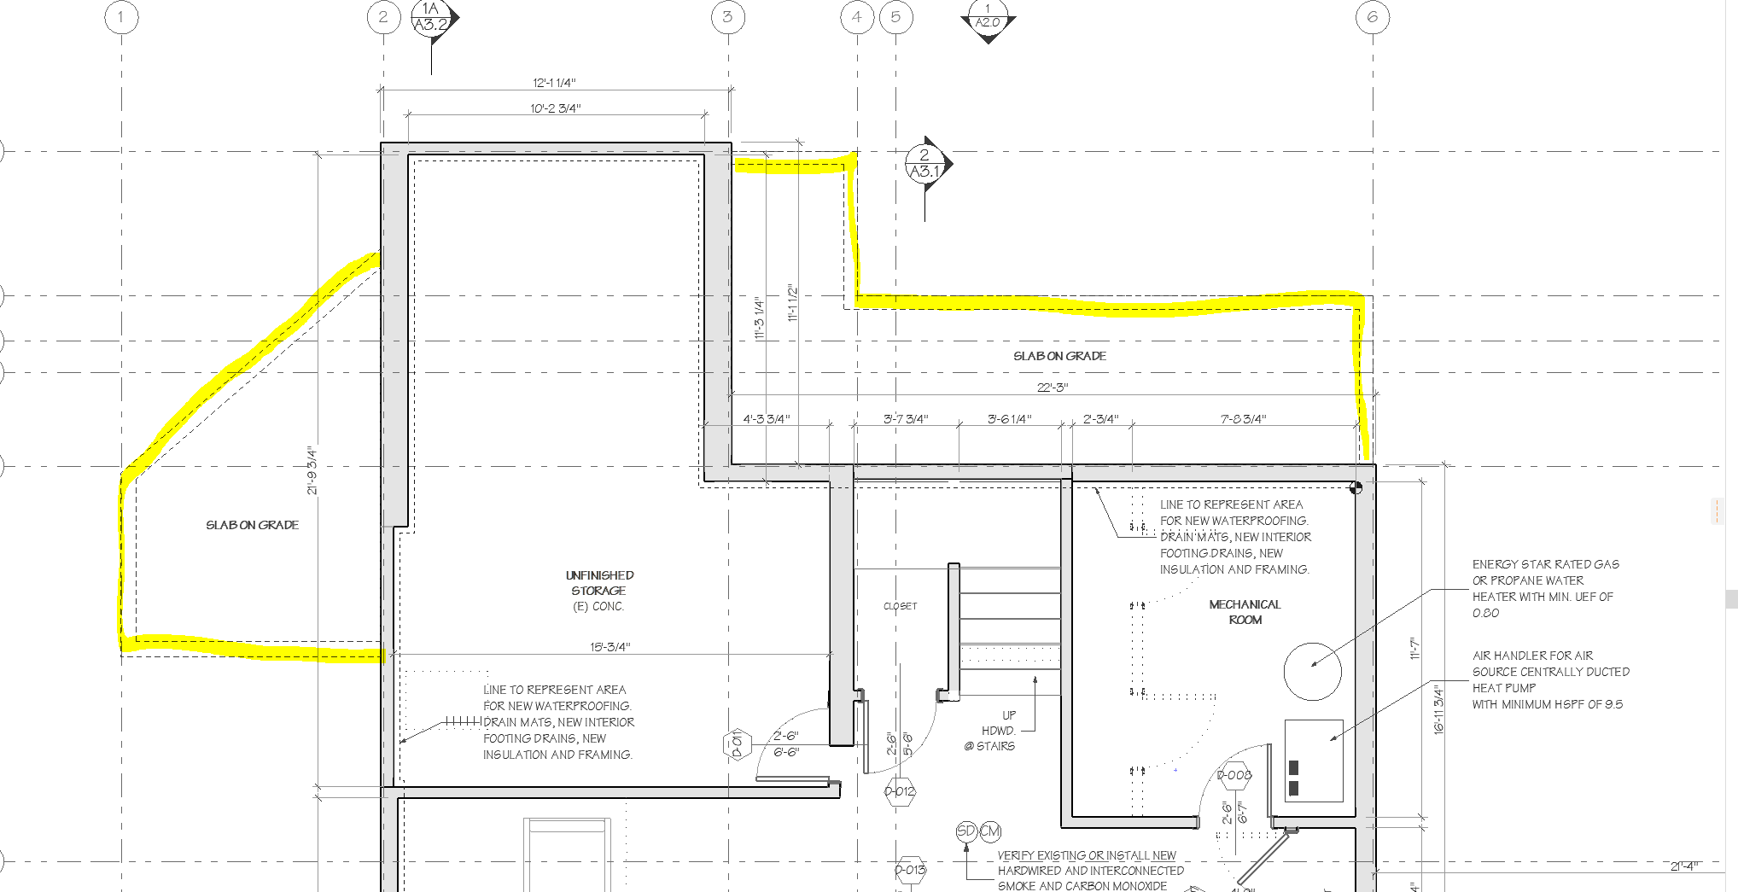

Please refer to revised structural plans and details, and 2/A3.1

The awning at the basement level above the exterior swing door has been revised. The steel posts have been removed and the structure of the awning has been revised. Please refer to 8/S3.3 for the revised structural detail and 4/A3.2

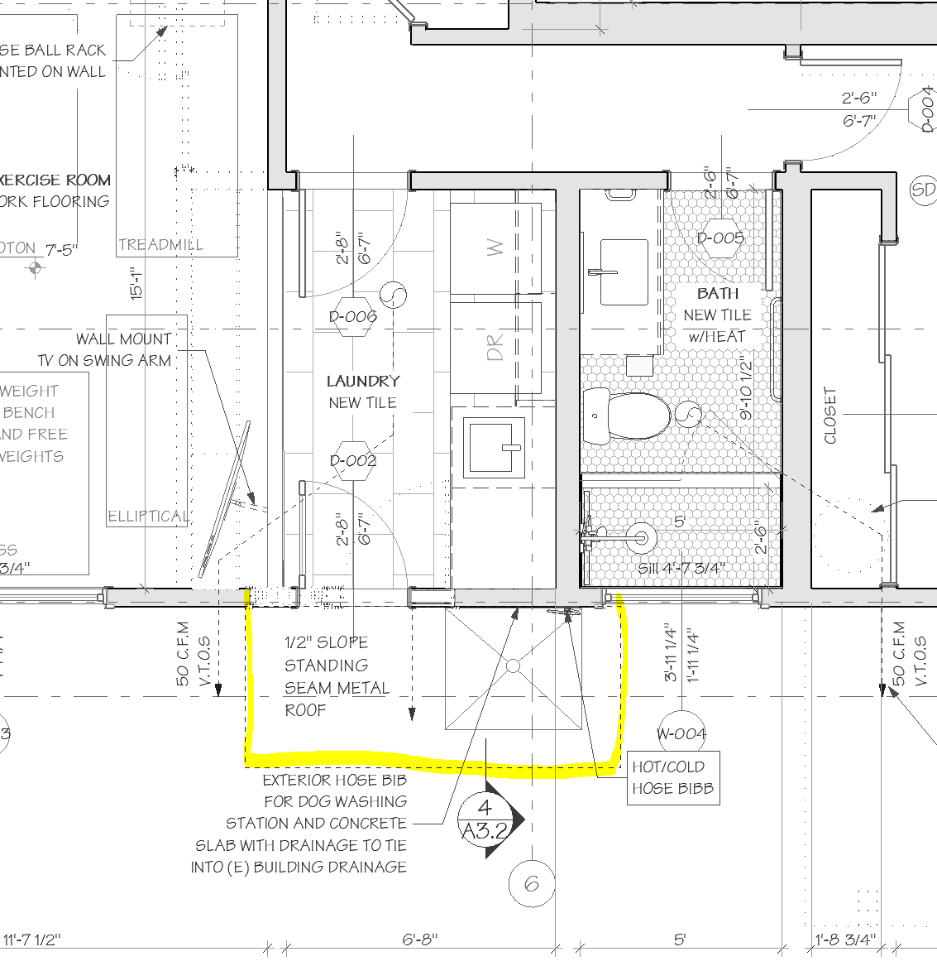

- Window sizes have changed incrementally throughout. These changes occurred based on window manufacturer dimensions when reviewing details and the window quote with our supplier.

